Module 2 – MERN stack – HTML

**1)Task:**

**Create a simple HTML webpage that includes:**

**• A header (), footer (), main section (), and aside section ().**

**• A paragraph with some basic text.**

**• A list (both ordered and unordered).**

**• A link that opens in a new tab**.

**ANS:**

<!DOCTYPE html>

<html lang="en">

  <head>

    <meta charset="UTF-8" />

    <meta name="viewport" content="width=device-width, initial-scale=1.0" />

    <title>Document</title>

  </head>

  <body>

    <header style="align-items: center; justify-content: center">

      <h1>Tops Technologies</h1>

    </header>

    <main>

      <aside>

        <p style="width: 30%; height: 30%; float: right; background: gray">

          Lorem ipsum dolor, sit amet consectetur adipisicing elit. Veniam odit

          est voluptatum neque a temporibus suscipit recusandae necessitatibus

          nulla ullam optio totam, atque reiciendis ad facilis vel dolorem,

          voluptatibus repellat ipsum voluptatem tempore hic. Voluptate

          repudiandae omnis quae autem odio. Enim illum minus voluptas

          temporibus quisquam, natus facere saepe quos.

        </p>

      </aside>

      <section>

        <ol>

          <li>Tea</li>

          <li>Cofee</li>

          <li>Cold Drink</li>

        </ol>

        <ul>

          <li>Tea</li>

          <li>Cofee</li>

          <li>Cold Drink</li>

        </ul>

        <dl>

          <dt>Tea:</dt>

          <dd>cold tea</dd>

          <dd>hot tea</dd>

          <dt>Cofee</dt>

          <dd>Cold cofee</dd>

          <dd>Hot cofee</dd>

        </dl>

      </section>

      <a href="https://www.google.com/">Google</a>

      <p>

        Lorem ipsum dolor sit amet consectetur adipisicing elit. Dicta totam a

        eum, nisi eveniet quis, at quidem, pariatur similique nulla rerum ullam?

        Quod blanditiis quos dolore! Eveniet inventore suscipit molestiae?

      </p>

    </main>

    <footer style="justify-items: center"><p>&copy; Tops Pvt Ltd.</p></footer>

  </body>

</html>

**Output:**

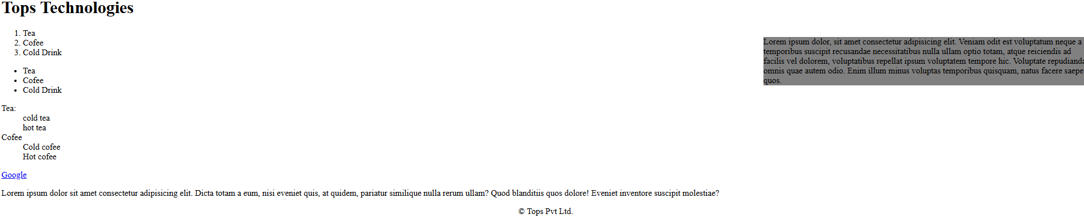

**2) Task:**

Create a product catalog table that includes the following columns:

• Product Name

• Product Image (use placeholder image URLs)

• Price

• Description

• Availability (in stock, out of stock)

Additional Requirements:

• Use thead for the table header.

• Add a border and some basic styling using inline CSS.

• Use colspan or rowspan to merge cells where applicable.

**ANS:**

<!DOCTYPE html>

<html lang="en">

<head>

    <meta charset="UTF-8">

    <meta name="viewport" content="width=device-width, initial-scale=1.0">

    <title>Document</title>

</head>

<body>

    <table border="1" cellspacing="0" cellpadding="20">

        <thead>

        <tr>

            <th>Product Name</th>

            <th>Product Image</th>

            <th>Price</th>

            <th>Description</th>

            <th>Availability</th>

        </tr>

        </thead>

        <tr>

            <td>Smart Watch</td>

            <td> <img src="https://m.media-amazon.com/images/I/41Q+MNft5ML._SY300_SX300_.jpg" alt="" width="100" height="100"></td>

            <td>&#8377;25000</td>

            <td>Fitness tracker with GPS</td>

            <td>In Stock</td>

        </tr>

        <tr>

            <td>Wireless Earbuds</td>

            <td><img src="https://m.media-amazon.com/images/I/21Y3xVnL0BL._SY300_SX300_QL70_FMwebp_.jpg" alt="" width="100" height="100"></td>

            <td>&#8377;9999</td>

            <td>Bluetooth, noise cancellation</td>

            <td>Out of Stock</td>

        </tr>

        <tr>

            <td>Laptop Stand</td>

            <td><img src="https://m.media-amazon.com/images/I/51QfGF-W7bL._SX300_SY300_QL70_FMwebp_.jpg" alt="" width="100" height="100"></td>

            <td>&#8377;19000</td>

            <td>Adjustable aluminum stand</td>

            <td>In Stock</td>

        </tr>

        <tr>

            <td>Phone Case</td>

            <td><img src="https://m.media-amazon.com/images/I/315CGam+ouL._SY300_SX300_.jpg" alt="" width="100" height="100"></td>

            <td>&#8377;8000</td>

            <td>Soft silicone case for iPhone</td>

            <td>In Stock</td>

        </tr>

        <tr>

            <td>USB Charger</td>

            <td><img src="https://m.media-amazon.com/images/I/31uxpTfYtCL._SX300_SY300_QL70_FMwebp_.jpg" alt="" width="100" height="100"></td>

            <td>&#8377;150</td>

            <td>Fast charging 2-port USB</td>

            <td>Out of Stock</td>

        </tr>

    </table>

</body>

</html>

**Output:**

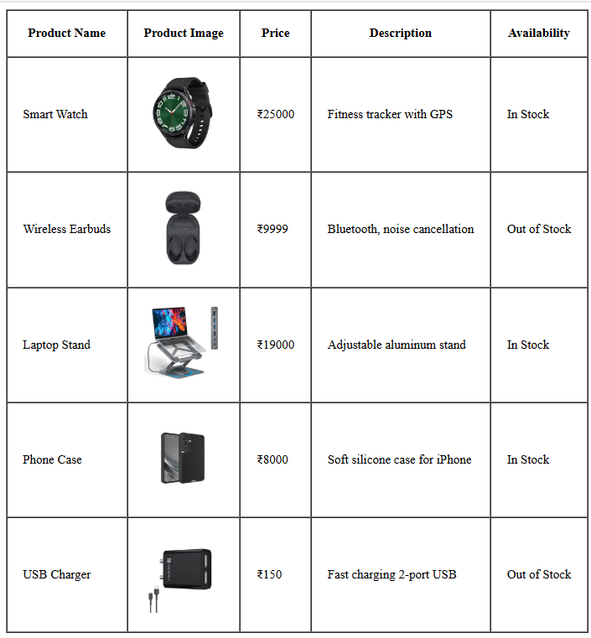

**3)Task:**

Create a contact form with the following fields:

• Full name (text input)

• Email (email input)

• Phone number (tel input)

• Subject (dropdown menu)

• Message (textarea)

• Submit button

Additional Requirements:

• Use appropriate form validation using required, minlength, maxlength, and pattern.

• Link form labels with their corresponding inputs using the for attribute.

ANS (with table tag)

<!DOCTYPE html>

<html lang="en">

  <head>

    <meta charset="UTF-8" />

    <meta name="viewport" content="width=device-width, initial-scale=1.0" />

    <title>CONTACT FORM</title>

  </head>

  <body>

    <form action="">

      <fieldset style="border: 1px solid black; display: inline-block">

        <legend>CONTACT FORM</legend>

        <table border="1" cellspacing="0" cellpadding="15">

          <tr>

            <td><label for="fullName">Full Name :</label></td>

            <td><input type="text" name="" id="fullName" maxlength="60" required/></td>

          </tr>

          <tr>

            <td><label for="eMail">Email :</label></td>

            <td><input type="email" name="" id="eMail" maxlength="70" required /></td>

          </tr>

          <tr>

            <td><label for="phoneNumber">Phone Number :</label></td>

            <td><input type="tel" name="phoneNumber" id="phoneNumber" pattern="[0-9]{10,11}" required /></td>

          </tr>

          <tr>

            <td><label for="subject">Subject :</label></td>

            <td>

              <select name="" id="subject" required>

                <option value="">-- Select Subject --</option>

                <option value="general">General Inquiry</option>

                <option value="support">Support</option>

                <option value="feedback">Feedback</option>

                <option value="other">Other</option>

                <br />

                <textarea name="" id="" placeholder="type here..."></textarea>

              </select>

            </td>

          </tr>

          <tr>

            <td colspan="2" align="center">

              <input type="submit" name="" id="" /><input

                type="reset"

                name=""

                id=""

              />

            </td>

          </tr>

        </table>

      </fieldset>

    </form>

  </body>

</html>

**Output:**

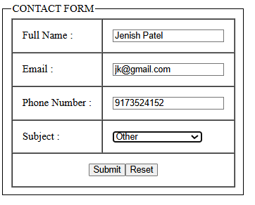

**ANS: (without table tag) :**

<!DOCTYPE html>

<html lang="en">

  <head>

    <meta charset="UTF-8" />

    <meta name="viewport" content="width=device-width, initial-scale=1.0" />

    <title>CONTACT FORM</title>

  </head>

  <body>

    <form action="">

      <fieldset style="border: 1px solid black; display: inline-block">

        <legend>CONTACT FORM</legend>

        <table>

          <tr>

            <td><label for="fullName">Full Name :</label></td>

            <td>

              <input

                type="text"

                name=""

                id="fullName"

                maxlength="60"

                required

              />

            </td>

          </tr>

          <tr>

            <td><label for="eMail">Email :</label></td>

            <td>

              <input type="email" name="" id="eMail" maxlength="70" required />

            </td>

          </tr>

          <tr>

            <td><label for="phoneNumber">Phone Number :</label></td>

            <td>

              <input

                type="tel"

                name="phoneNumber"

                id="phoneNumber"

                pattern="[0-9]{10,11}"

                required

              />

            </td>

          </tr>

          <tr>

            <td><label for="subject">Subject :</label></td>

            <td>

              <select name="" id="subject" required>

                <option value="">-- Select Subject --</option>

                <option value="general">General Inquiry</option>

                <option value="support">Support</option>

                <option value="feedback">Feedback</option>

                <option value="other">Other</option>

              </select>

            </td>

          </tr>

          <tr>

            <td><label for="">Message :</label></td>

            <td><textarea name="" id="" value="Type here..."></textarea></td>

          </tr>

          <tr>

            <td colspan="2" align="center" cellspacing="20">

              <input type="submit" name="" id="" /><input

                type="reset"

                name=""

                id=""

              />

            </td>

          </tr>

        </table>

      </fieldset>

    </form>

  </body>

</html>

**Output:**

